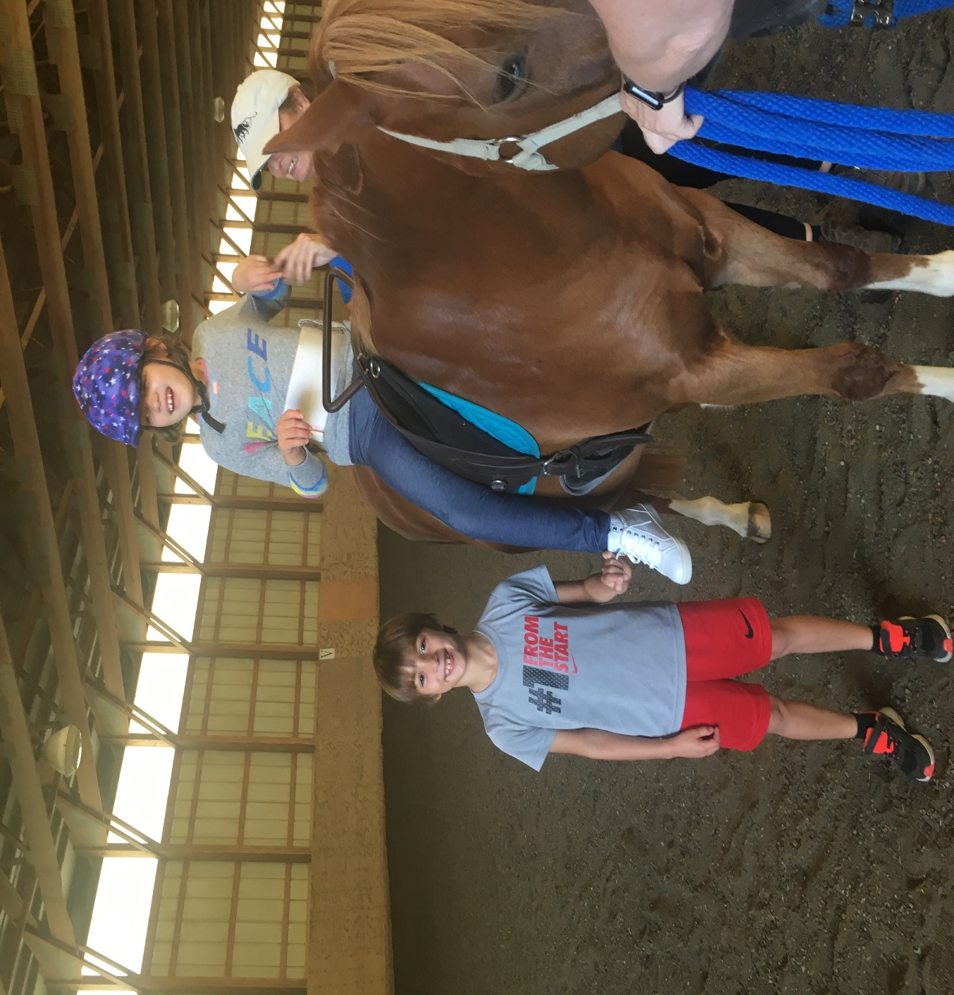

SuMMit

Centre

Re-Opening Plan

April 19, 2020

SuMMit Centre for Therapeutic Riding
Authored by: Karen Garland

ReEntry Plan

Phased Entry
Client services will be offered using a strict phased entry approach. The phases and their descriptions will be detailed in this document. First, and foremost, policies and procedures outlined in this plan are subject to change, at any time, based on local and federal mandates that are issued, or suggested, during this pandemic.
“Crisis either causes regress or progress depending on the will of the people.”
― Abhijit Naskar
It is important the implementation of ReEntry is led by a strong and cohesive team that emphasis;
- SAFETY First
- ORGANIZATION
- POSITIVE AND MOVE FORWARD ATTITUDE
PHASES

Planning
Purpose: This crucial stage must set the centre “team” up for success. This phase will focus on SAFETY of our clients, staff and equines in an organized fashion with strong communication among the team.
Time Frame: This phase should start 3 weeks before the start of the next Phase-Initial Opening Phase.
Breakdown of Tasks
Staff & Clients
- Staff virtual Zoom meeting to review procedures for BOTH staff and clients before they come on site to start with this phase.
- Although this is not an easy question, what staff will be part of this phase? I would limit the participation so oversight is easier and fast modifications can be made efficiently.
- Earmark the clients you will start with using the criteria outlined in the next phase. Start with 25% the first week, working up to no more than 50% during the Re-Opening phase.
- Based on the clients selected in the Initial Re-Opening phase, Earmark a select group of horses that will be used in this Initial Re-Opening phase and concentrate on getting them in shape.
Facility Set Up
- Activity Map- A CLEAR map will be drawn that will clearly define the “activity area” for our clients. This will be the specific areas, and flows that all will follow while at our facility. This should include; barn entry, grooming area (may not happen in the Opening Phase), riding area, spectator area, bathroom and barn exit (hopefully different from entry). Will you limit the number of family members per lesson? Will you require temps be taken to proceed beyond the entry point?
  - Mark Off (maybe caution tape) those areas not available to clients.
  - Entry Point/Exit Point
    - Clear signage & Map to clearly direct clients to “activity areas” and non-designated areas. Signage should include procedures/policies for that activity point, such as masks, social distancing and hand sanitizer.
    - Supply table-hand sanitizer, face mask (for those that forget), disinfected wipes, gloves, memos. Have proper disposal containers.
    - Temperature Check?
    - Limit Spectators? We will to only 2 per person.
  - Activity Points-Each activity point should have signage and supplies for procedures. Have fun with this and come up with a theme for these points.
  - Supplies will need to be available at ALL of these activity points. Do you have DISINFECT WIPES, GLOVES, FACE MASKS? Remember, cleaner is NOT the same as a disinfectant. A disinfectant will have an EPA # shown on the label. Will you provide masks or expect clients to bring their own?
  - Cleaning Procedures for activity points will need to be identified and communicated to the individual that is responsible. Clearly identify that individual so there is no breakdown on responsibility. Will this area be cleaned after @ person has entered, by time, some other criteria that has been defined by appropriate safety measures.
Insurance & Legal
- Insurance-contact your insurance agency to determine if there is additional agreements, modified boarders agreement, or medical paperwork that will need to be done. Get this paperwork available so it can be quickly retrieved before the first lesson.
- Legal-Contact your attorney to determine what your legal responsibilities are and make sure they are incorporated in your activity points. Will you or should you require a Dr. note?
COMMUNICATION!
- Create a simple re-entry plan that will be emailed to each client. Keep it as simple as possible!
- Post the re-entry plan on your website and Facebook page.
  - A cute video walking through the activity points will be appreciated and reduce anxiety. If you do not have a YouTube channel, this might be a great time to set one up as more video suggestions are coming.
  - Links to local laws on businesses would be helpful as well.
  - Update these re-entry postings weekly so parents know to look for those updates and you give yourself flexibility in making changes as needed. Clearly identify the update date on any communication! Make it clear that things may change and that they must be proactive in keeping updated.
- Volunteers-Insist on a volunteer meeting (virtual) and via video, go through the points of entry and the expected procedures. Post the video so they are able to review it. Will they have to wear masks from entering to leaving the barn? If so, you will need to have masks in case they do not have them.
- Cleaning- A thorough disinfecting (not cleaning) of all activity points will need to be done as well as sanitizing all equipment (saddle pads, hats, reins, saddle and any game items you plan to use).
- Review-with any other groups or boarders that share the facility, so everyone is on the same page and make sure everyone is following the SAME procedures.

Phase 1 Initial Re-Opening Phase
The starting point needs to be well orchestrated with simple, clear and concise communication.
- How to determine the first group of clients?
- Less medically vulnerable
- Requires fewer volunteers
- Activities that are easier to enforce social distancing
- Zoom conference with parents PRIOR to start up to go through activity areas and procedures. Eliminate any anxiety and make sure they know the rules that need to be enforced with their kids and emphasis they will be responsible for making sure they make their kids follow the rules! Will you need to make some changes or accommodations for a certain rider? If so, you might want to wait and put them in the next phase.
- Take previous group lessons and break it down to 30 min. private.
  - Try to schedule the same horse for back to back lessons and maybe eliminate grooming for the first several weeks. Just meet the ring. This will eliminate the grooming activity point..less stress.
  - . Depending on the size of your indoor, you may be able to divide the indoor and give 2 lessons at the same time at opposite ends of indoor.
- Stagger your lessons so people are not coming and going at the same time.
- Limit the number of family members that come and watch.
- If there are family members that take lessons, offer them a group lesson.
- Only put out a couple of helmets (easy to clean) and saddles to use! Have bandanas available to use under helmets.
- After each ride disinfect (not clean) the reins, saddle and change the saddle pad. Must have supplies in indoor if you are meeting students there and switching riders. Define and communicate whose responsibility this will be. This will mean more laundry (assign and have supplies). Have a safe and available trash for these items.
- At which point will you have the students use face masks? Instructors must use face masks during lessons.
- Don’t move to Phase 2 until all procedures are ironed out.
- Offer virtual classrooms (YouTube Channel) on a weekly basis that will focus on grooming and care since they will not be doing (or on a limited basis).
- On social media, continue to do activities for those that are not riding yet. Virtual Clue or Scavenger Hunt and fun. Do a Plop of Gold fundraiser.
- Evaluate and change any procedures/policies/paperwork/timelines before you start Phase 2.
Phase 2 Limited Opening
- 4-6 weeks after Phase 1 starts, Phase 2 can start IF local and federal guidelines allow.
- First, evaluate and change any procedures that need to be re-written? Update all communications prior to a Zoom meeting to inform parents…the same as Phase 1.
- Start with Semi-private groups and work up to larger groups as everyone feels safer to do that.
- How will you enforce social distancing during grooming and riding? This should start with smaller groups and work up to larger. Will you eliminate grooming and just have show-ups until it is safe? If so, we will rely on volunteers even more..
- Would it be best to assign different groups to different areas-divide indoor and assign a group to the outdoor.
- Continue all of the safety procedures after each lesson. Keep supplies up and clearly assign tasks so they are not overlooked.

