April 15, 2020 - COVID-19 Resources
Compiled by Chrissy Stout

WEBINAR: Horse Biosecurity & Facility Sanitation
Joe Lyman, DVM
Published April 15, 2020
https://youtu.be/cuONqhwPlmQ
1:04:31

Screenshot from 38:47
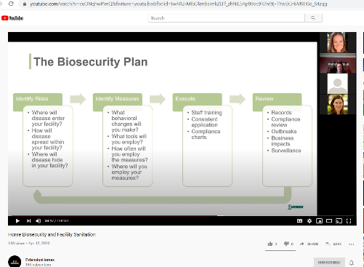

List N: List of disinfectants for use with COVID-19 (aka SARS-CoV-2)
https://www.epa.gov/pesticide-registration/list-n-disinfectants-use-against-sars-cov-2

See handwritten notes at end for more information from webinar

Disinfection Protocol
EDCC - Equine Disease Communication Center
Excerpt from April 15, 2020
http://www.equinediseasecc.org/biosecurity/disinfection

General disinfection protocol:
- Remove all organic matter- *Surfaces cannot be disinfected if organic matter is present.* Scrub surfaces with warm, soapy water to remove all traces of organic matter including dirt, feces, saliva and mucous.
- Allow surface to dry before applying a disinfectant.
- Disinfect- After scrubbing the surface, use an approved disinfectant such as bleach (recommended at a strength of 1 part bleach to 10 parts water) or accelerated hydrogen peroxide or a phenolic. Be sure to follow label directions for use including precautions that workers should be taking in applying the product used.
- Allow surface to dry before using the vehicle.
- Remember to disinfect crossties and under floor mats as well- floor mats should be pulled up, scrubbed, and sprayed with a disinfectant, as should the floor beneath them. Crossties should be cleaned of organic matter and disinfected.

Disinfection Resources (EDCC):
The Importance of Cleaning to Disinfection (article), EDQ
Characteristics of Selected Disinfectants (chart), CFSPH- Iowa State University
Cleaning and Disinfecting Protocol (sign), CSFPH- Iowa State University
Stall Cleaning/Disinfection Series Part 1: Cleaning (video), The Horse
Stall Cleaning and Disinfection Part 2: Disinfection (video), The Horse
How to Clean/Disinfect Horse Equipment (video), The Horse
How to Clean and (not quite) Disinfect Leather (video), The Horse
How to Clean/Disinfect Water Buckets and Troughs (video), The Horse
For Vets: Disinfection 101 -CFSPH, Iowa State University

EDCC Coronavirus Resources:
http://equinediseasecc.org/coronavirus-resources

The Equine Disease Communication Center is committed to helping owners stay current on the fast-changing health recommendations surrounding the COVID-19 health crisis. As always, our priority has been to protect and improve the health and horses in North America. In order to help mitigate and protect horses from the spread of disease and help keep you and your horse safe, we have created this resource center that will be updated as necessary to reflect the current information.

What We Know about COVID-19
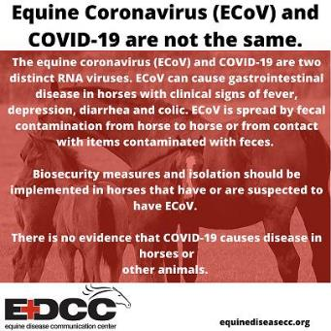

Equine Coronavirus and COVID-19 are NOT the same
The equine coronavirus (ECoV) and COVID-19 are two distinct RNA viruses. ECoV can cause gastrointestinal disease in horses with signs of fever, depression, diarrhea and colic. To date there is no evidence that COVID-19 causes disease in horses or other animals.
For more information about the differences in equine coronavirus (ECoV) and COVID-19 go to the EDCC’s comparison and for more information about ECoV go to the owner fact sheet.
Horse Owner Resources
- American Association of Equine Practitioners
Preventing the Spread of COVID-19 in Equestrian Facilities
- American Association of Equine Practitioners
COVID-19 and Barn Safety Infographic
- American Veterinary Medical Association
FAQ’s for Pet Owners
- British Equine Veterinary Association
Don't Give Your Vet the Virus
- Ontario Animal Health Network
Caring for Your Horse During a Pandemic
- Stable Management
Tips for Equine Businesses During COVID19
Additional Resources
- Centers for Disease Control and Prevention (CDC)
Coronavirus Disease FAQ
Coronavirus Disease Information for Travel
- EDCC
Biosecurity at the Barn
- Kentucky Department of Agriculture
COVID-19 Equine Activities
- USDA
COVID-19 Resources
- EDCC
Spanish Translation of COVID-19 Resources

CDC - Cleaning and Disinfection Guidelines
https://www.cdc.gov/coronavirus/2019-ncov/prevent-getting-sick/cleaning-disinfection.html?CDC_AA_refVal=https%3A%2F%2Fwww.cdc.gov%2Fcoronavirus%2F2019-ncov%2Fprepare%2Fcleaning-disinfection.html#disinfect

CDC - Prevent Getting Sick
https://www.cdc.gov/coronavirus/2019-ncov/prevent-getting-sick/index.html

USEF Biosecurity Measures for Horses at Home and at Competitions
https://www.usef.org/forms-pubs/WkptpXp1g4c/biosecurity-measures-for-horses-at-home

American Horse Council Resources
https://www.horsecouncil.org/covid-19-resouces/

WEBINAR: HOPE Beijing COVID Response
Amy Tripson - March 27,2020
https://youtu.be/hymFRf_VIgg

AAEP Infographic
https://www.facebook.com/AAEPHorseDocs/photos/a.347949547690/10156721676237691/?type=3&eid=ARATKgST7qAfUqY4dL1qmCEYwGqkDbkKS32g4R-2vD4kncmDeO8lDxckpehPJcC7d1kE5a96ExUCh1-I&__tn__=EHH-R

