Sidewalker & Coach Training Packet

What is a Sidewalker and Coach Volunteer?
SIDEWALKER (Non-verbal part of support team)
This individual will be responsible for:
- Maintaining complete and accurate personal information on file in the office.
- Wearing appropriate clothing per dress code guidelines
- Arriving 30 minutes before beginning of scheduled riding session to meet with the instructor
- Safety of the rider as directed by the instructor.
- Walking and/or jogging beside the horse providing support to the rider as directed by the instructor.
- Understand the role within the team as it may differ for each client but understands to limit communication directed at rider as this is the Coaches responsibility.
- Following safety guidelines as detailed by [PROGRAM NAME].
- Caring for tack and equipment in a manner to preserve its life of usefulness.
- Adhering to all [PROGRAM NAME] policies and procedures.
A volunteer must have the following qualifications to fill the position of SIDEWALKER:
- Be 16 years of age or older
- Completion of a [PROGRAM NAME] Sidewalker/Coach Trainign and Skills Check Off and a minimum of one (1) additional refresher training session annually.
- Aware of acceptable horse behavior and movement.
- Ability to communicate with instructor, other volunteers, and participant.
- Physicaly, cogntitivley, and emotinally able to support a participant in an adaptive riding class.

COACH (Verbal part of the support team)
All Side-walker duties AND:
- Use instructor’s information to help vocalize instructions to rider
- Encourage rider throughout class time
- Explain instructor’s instructions in a way that makes sense to the individual rider
- Greet/wait with rider at the white sign in the waiting area
- Check over the helmet fit of the rider
- Escort rider to waiting area after class
A volunteer must have the following qualifications to fill the position of COACH:
All Side-walker qualifications AND:
- Basic understanding of disabilities served.
- Basic knowledge of appropriate coaching techniques.

The Programs at [PROGRAM NAME]
- Adaptive Riding (recreational)- Adaptive Riding, Show Team, Games-Based
- Adaptive Horsemanship (recreational)
- Hippotherapy (therapy)
- Equine Assisted Learning (recreational)
- Equine Facilitated Mental Health (therapy)

The word “Therapy”
- A majority of our programs are NOT therapy!
  - Only Equine Facilitated Mental Health and Hippotherapy are THERAPY because a state recognized, certified therapist is helping to facilitate the session
  - All other programs are RECREATIONAL
- What is ‘Therapeutic’?
- What is ‘Therapy’?
- Why do we use the word ‘Adaptive’ when referring to a majority of our programs?

Who is Served at [PROGRAM NAME]?
- Most common disabilities served at [PROGRAM NAME]:
- Autism Spectrum
  - Low functioning vs. high functioning
- Cerebral Palsy (CP)
- Traumatic Brain Injury (TBI)
- Multiple Sclerosis (MS)
- Sensory Processing Disorders
- What is comorbidity?

Why Equine Assisted Activities?
- Movement of the horse
- Sensory input
- Life skills
- Social skills
- The one activity that is ‘theirs’
- And so much more….

NOTES:

Coaching & Side-walking Tips
- How do you talk to someone with a disability?
  - Talking to a kid vs. adult
  - Simplifying instructions vs. ‘talking down’ to someone
- Processing time delays- incoming vs. outgoing information
- Internal vs. External Cueing and why use external
  - Internal cueing= straighten your back and sit up tall
  - External cueing = we are going to sit tall by stretching our head to the sky
- Benefits of using eye contact and count downs
- Cueing the rider at the right time (it’s an art!)
  - Don’t over cue (focus on one or two things)
- Importance of not talking over the instructor/negating what they just said
- When and why we use ‘hand over hand’ coaching
- Handling rider outbursts
- When to call over the instructor
  - Trouble getting a rider to correctly do something
  - Behavior outbursts
- The benefit of letting your rider make ‘safe’ mistakes
  - The harm of false praise
- The harm of false promises
  - Embrace the skill!
- The harm of false praise
- Importance of YOUR positive words
Things that are NOT your responsibility (yay!)
- Parents asking about progress or why their rider did not do a certain skill
- Payments
Verbal Commands for the Horse:

- Whoa = Stop
- Walk On= walk
- Trot (cluck) = Trot
- Canter (smooch) = Canter
- Easy = slow down

The supportive holds at [PROGRAM NAME]

- Thigh Hold
- Cuff Hold
- Heel Hold
- Gait Belt

Notes:

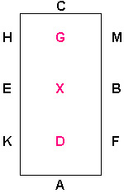
Basic Arena Patterns
Serpentine
- Number of loops in a serpentine can vary from three to five…or more.
- Note the straight line across the arena to each turn.
- Pattern: straight line-turn-straight line

Arena Letters
- Letters are commonly used in lessons. Please become familiar with their layout.
- ‘X’ is referenced the most in lessons since it marks the center of the arena

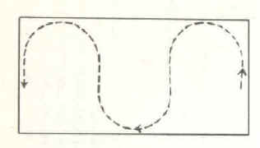

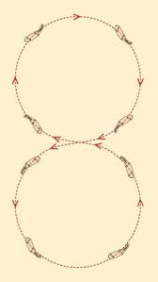
Figure 8
- This pattern is basically two circles put together.
- Start this pattern in the MIDDLE of the two circles. The left and right half should be the same size
Lazy 8
- This pattern is a more relaxed version of a figure 8. Often it is paired with an arena obstacle like a barrel
- Notice how each side is more oval than circle. The turns are not as ‘harsh’.

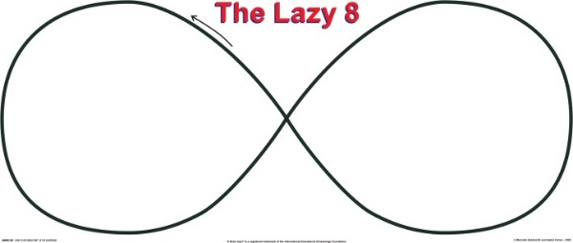

Change of Rein on the Rail
- Change direction on the rail by turning towards the center of the arena (‘x’) then completing turn by heading back towards the rail.
- Please do not turn horse to tight during this exercise.
- Letter practice:
  - Diagram to right shows a change of rein on the rail at F

Change of Rein Across Diagonal
- Change of rein must ‘originate’ from second corner on the short wall.
- Image to the right is a common change of rein across the diagonal. There can also be a change of rein across a short diagonal.
- Letter practice:
  - Change of rein F X H
  - Short change of rein across diagonal K to B

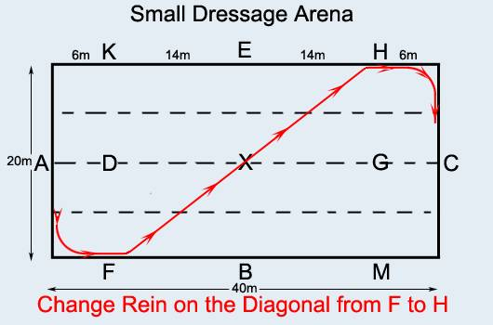
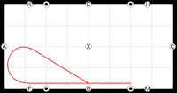

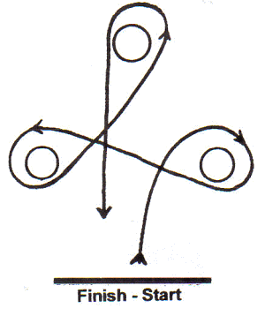
Barrel/Clover Leaf Pattern
Notice that you start and finish at the same spot.
This pattern can be taken by doing a:
Right-left-left turn (as shown)
Or
Left-right-right

Take care not to turn to tight around the barrels for the horse and rider’s safety and comfort.

Quarter Line

Center Line

Basic Arena Etiquette/Terminology
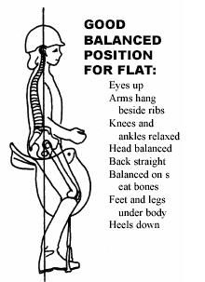
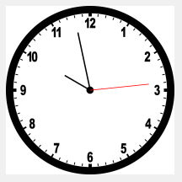
Terminology
- Tracking right- Clockwise
- Tracking left- Counter clockwise

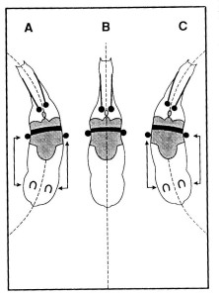
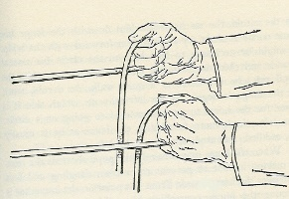
Proper riding position

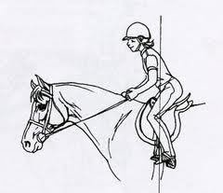

Holding the reins with two hands
“Bending”
“2-point”

- Inside/Outside rein- Typically, the inside rein is towards the middle of the arena. Outside rein is towards arena rail.
- Trot (jog)- 2 beat (1-2-1-2) gait of the horse that is faster than a walk. Riders can sit or post this gait. This is similar to a human jog
- Canter- 1 beat gait (1-2-3-1-2-3) of the horse that is faster than the trot. This gait is not typically done by riders at [PROGRAM NAME] as this is a very advanced skill. Often the word ‘run’ is incorrectly used to describe this gait
- Off-side- the right side of the horse
- Near-side- the left side of the horse
Arena Etiquette:
- Spacing: Always allow ample space between horses (3 horses or 2 big elephants)
- Passing other horses & Teams:
  - If you are passing another horse to do as quickly and as safely as possible
  - Always pass to the inside of another horse (do not squeeze between another horse and the arena rail.
  - If you are getting close to a horse, instead of stopping your team can circle or cut across the arena to where there is more room.
  - If you have to pass a horse going the opposite direction, always past LEFT AND LEFT (just like when you’re driving)
- Direction: If you are not the first one in the arena, go the same direction as those already inside
Safety Reminders:
- Dress weather appropriate-
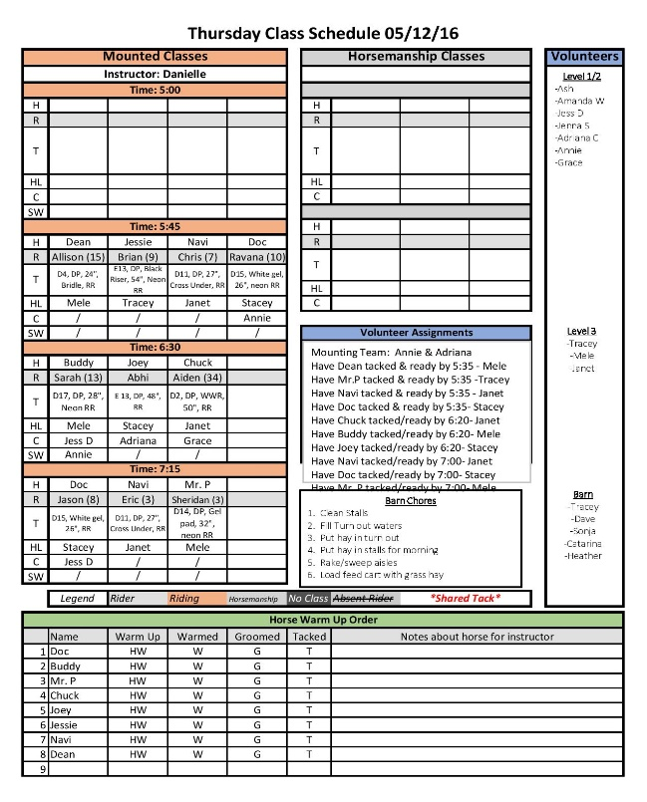
  - Cold weather: No hands in pockets at any time, please bring gloves when it gets cold out
  - Hot weather: no low cut tops, ripped pants/shirts (safety reasons), shorts need to be no higher than a couple inches above the knee.
- Be sure to stay hydrated
- Advocate for yourself if you are not feeling well
- Don’t be afraid to say “I don’t know” or to ask questions
- Do not run to catch up to your horse when side-walking, communicate with your team and let them know if you are falling behind
- Do not lean on horses
- Do not bump or hit horses on the stomach to get them to go faster
- If an obstacle falls or gets knocked down, do not attempt to pick it up
- If a rider wishes to take off a jacket/gloves/etc. stop the horse and call over the instructor
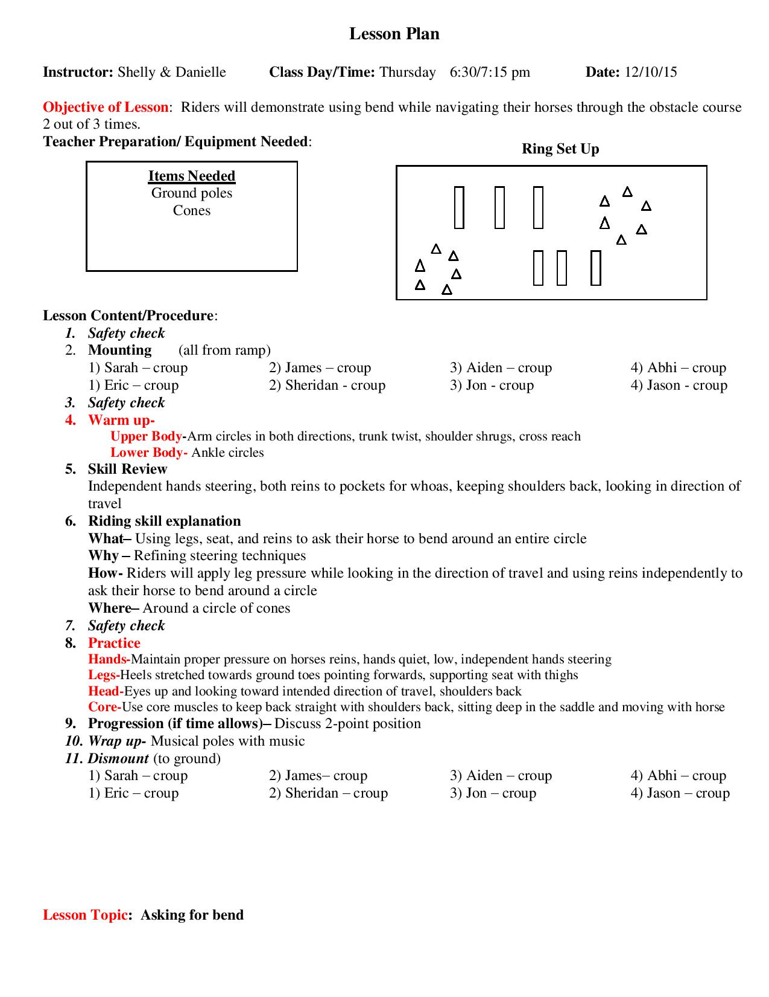
- If you have any concerns about the horse/rider/volunteers/staff that you are assigned advocate for yourself

