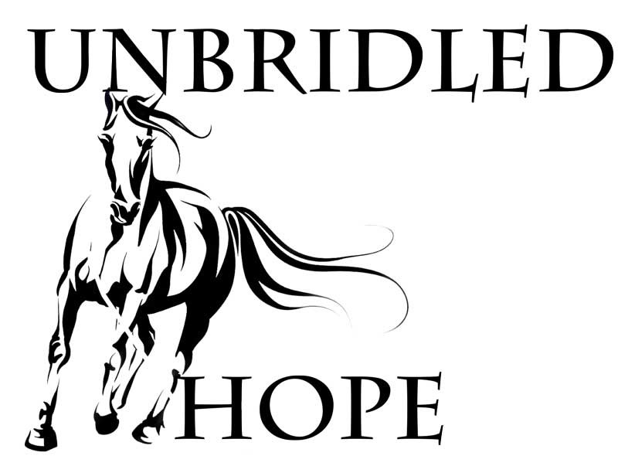  2020 Virtual Cinco de Mayo Horse Show  Judges: Kelley Chaffee (Showmanship, Equitation, Horsemanship, & Trail), Michelle Kauffman (Stick Horse Horsemanship)  Date: All entries due April 30, 2020  Cost: $10 per class or $32 for all 4 classes, $5 for Stick Horse class  Class placings will be posted on our Facebook page. The first-place video in each category will be posted as well.  Ribbons will be given for 1st-8th placings in each class.  All ribbons will be mailed after the show.  Class Divisions:  *Tiny Tot – 7 & Under  *Children – 8-12  *Intermediate 13-18  *Senior – 19-39  *Sr. Sr. – 40 & over  How to Participate:  - Fill out your google entry form.  - Pay via Venmo @Unbridled-Hope  - Video tape pattern. Email it to unbridledhopeidaho@gmail.com with your name and class name. i.e.: melissachild-showmanship  All proceeds go to care of the horses at Unbridled Hope Inc. _ 501©3 nonprofit. Thank you for attending our show and supporting Unbridled Hope. | Classes  Showmanship  Equitation  Horsemanship  Trail  Stick Horse Horsemanship  Unbridled hope  Mailing: PO Box 372  Rigby, ID 83442  Physical: 1689 E 113th S  Idaho Falls, ID 83404  Telephone 208-521-9946  Email unbridledhopeidaho@gmail.com  Web Address unbridledhopeidaho.com

