Important [center name] Policies

[center name] Sick Policy
To help keep everyone happy and healthy at [center name] we would like to update you on our Sick Policy. Many of the individuals we serve can become very sick, very easily due to weak immune systems so it is very important that everyone adhere to our Sick Policy for the wellbeing of all.

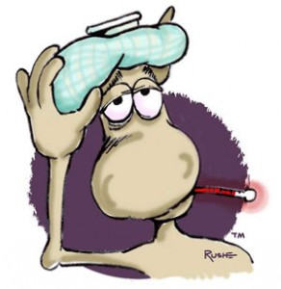
Participants (Riders, Hippo Clients, etc) and Volunteers must be free of the following symptoms and/or conditions for 24 hours before arriving at [center name].

- Temperature of 101 or higher**
- Vomiting
- Two or more cold symptoms**
- Undiagnosed rash on the body
- Colored mucus discharge
- Cloudy discharge from the eye(s)
- Any communicable disease

** Symptoms and/or fever must remain absent without the use of Tylenol, Motrin, or any other antipyretic.

If you have any of the above symptoms and/or conditions please contact your instructor directly ASAP. Credits are not issued in the case of absences due to sickness.

Ask Before You Snap!
Media Policy Regarding [center name] Participants and Equines
This policy includes, but is not limited to, ALL of Social, Digital, and Printed Media
We know how cute and lovable all of our horses are and that we have amazing Participants! However...some of the horses do not yet belong to [center name] and some Participants may have a non-consent for photos/videos. We need to respect the privacy of the owners and donors of all the horses and all our Participants by not posting and/or sharing photos, videos, or names of specific horses and Participants without permission from [center name] on social, digital, and printed media. Remember that you, as a Volunteer and/or Participant, have signed a Confidentiality Agreement which needs to be honored.
Please do not post photos/videos on any social media, website, print, etc without express permission from Horses Help Staff....make sure you "Ask before you snap" and share a photo and/or information of:
- ANY horse or goat
- ANY Participant in ANY of our Programs
- Any information that is outside of your area of responsibility at [center name]
- Providing information or speaking behalf of [center name] without specific permission
We love for people to share photos and spread the word about [center name]…just check with staff first
Please be aware that this policy applies to everyday activities and classes. Special Events such as the [special event 1], [special event 2], etc. are considered an ‘implied consent’ event and photos (not information) are not as restricted.

If you have any questions regarding [center name] Sick Policy, Social/Digital/Printed Media Policy, or any other Policy please contact email@email.com

